**Requirement plan**

Admission system

**Contents**

List of table 2

1. Revision 3

2. Introduction 4

3. Requirement Management Plan 4

3.1 Roles and Responsibility 4

3.2 Requirement Schedule 5

4. Tools, Environments and Infrastructure 7

5. Document Template 8

# **List of table**

Table 1: Revision history 3

Table 2: Stage 1 description 5

Table 3: Roles and responsibility in stage 1 6

Table 4: Stage 2 description 7

Table 5: Roles and responsibility in stage 2 7

Table 6: Requirement Schedule 8

# **Revision**

|  |  |  |  |  |
| --- | --- | --- | --- | --- |
| **No** | **Version** | **Update date** | **Author** | **Content** |
| 1 | 0.1 | 18/11/2013 | Khang Huynh | Create Requirement plan document |
| 2 | 0.2 | 19/11/2013 | Khang Huynh | Update Template |
| 3 | 0.3 | 20/11/2013 | Khang Huynh | Update Requirement Schedule |
| 4 | 0.4 | 23/11/2013 | Khang Huynh | Update process, description, roles and reponsibility |

Table 1: Revision history

# **Introduction**

The purpose of the Requirements Management Plan is to define the roles and responsibility of team member in requirement processes, define schedule and procedures to be used by the Deadline Team.

# **Stage 1**

## 3.1 Stage 1 Process

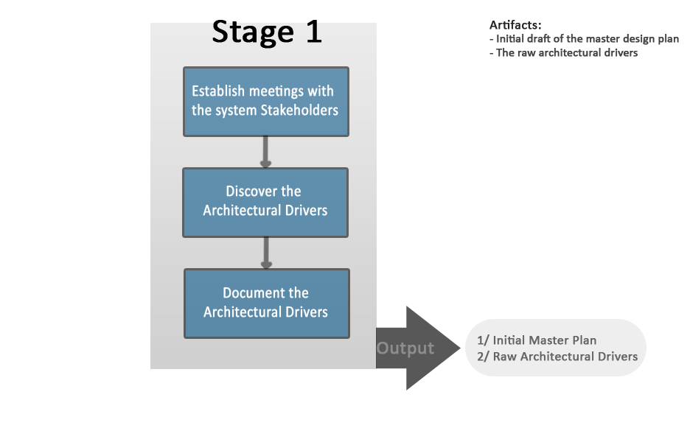

## 3.2 Stage 1 Description

|  |  |  |
| --- | --- | --- |
| No | Activities | Description |
| 1 | Establish meetings with the system Stakeholders | Establish the encounters between stakeholders and the architectural design team are structured to make the most efficient use of valuable time spent with the stakeholders. |
| 2 | Discover Architectural Drivers | Gathering as much information about what the stakeholders need and expect in the system. Gathering as much information as possible regarding the system architectural drivers to include high-level functional requirements, business constraints, technical constraints, and quality attributes. |
| 3 | Document the Architectural Drivers | Document and uses templates designed to capture information about the system architectural drivers include high-level functional requirements, business constraints, technical constraints and quality attributes. |

Table 2: Stage 1 description

## 3.3 Roles and Responsibility

|  |  |  |
| --- | --- | --- |
| **Role** |  | **Stage 1 recommended responsibility** |
| Managing engineer | Huy Ngo | - Create the initial master design plan  - Assist the requirements engineer in planning the architecture drivers elicitation  - Track efforts  - Update and replan master design plan based on actual data |
| Chief Architect | Phu Ta | - Work with the requirements engineer to elicit the requirements from the stakeholders.  - Focus on eliciting complete and measureable architecture drivers  - Assist the requirements engineering in capturing and documenting to collection of raw architecture drivers. |
| Chief scientist | Dao Khau | - Work with the requirements engineer to elicit the requirements from the stakeholders.  - The chief scientist should focus on technical issues associated with eliciting the architectural drivers.  - Assist the requirements engineering in capturing and documenting the collection of raw architecture drivers |
| Requirements Engineer | Khang Huynh | - Plan, coordinate, and facilitate the stage 1 architectural drivers elicitation workshops.  - Coordinate architectural drivers consolidation meetings.  - Compile the consolidated raw architecture drivers document. |
| Quality process engineer | Huy Nguyen | - Ensure that the ACDM (and other project processes) are being followed.  - Work with the requirements engineer to elicit the requirements from the stakeholders.  - Assist the requirements engineering in capturing and documenting the collection of raw architecture drivers.  - Coordinate a review of the raw architectural drivers document. |
| Support engineer | Chau Le | - Work with the requirements engineer to elicit the requirements from the stakeholders.  - Install, configure, and maintain the tools necessary to support stage 1 activities and any tools that can be established now to support the remainder of the project. |
| Production engineers | All Team | - Minimal support is usually required from production engineers. |

Table 3: Roles and responsibility in stage 1

# **Stage 2**

## 4.1 Stage 2 Process

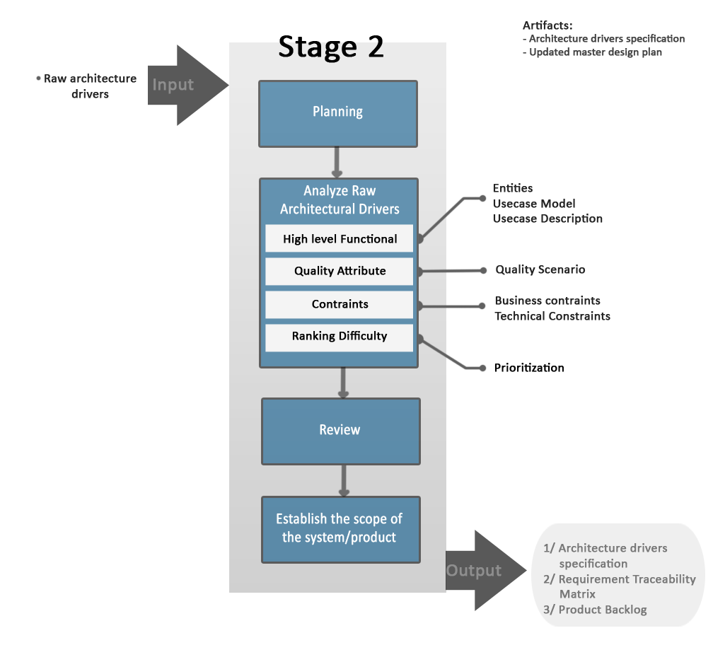

## 4.2 Stage 2 Description

|  |  |  |
| --- | --- | --- |
| **No** | **Activities** | **Description** |
| 1 | Planning | Planning the activities of the stage and updating the master design plan to reflect the time that the architecture design team estimates they will take in stage 2. |
| 2 | Analyze Raw Architecture Drivers | Analyze the consolidated raw architecture drivers information gathered in stage 1 to clarify and refine the architectural drivers |
| 3 | Review | After the architecture drivers specification is complete must review and formally accepted by the stakeholders. |
| 4 | Establish the scope of the system/product | Establish the scope, context, and size of the development effort. |

Table 4: Stage 2 description

## 4.2 Roles and responsibility

|  |  |  |
| --- | --- | --- |
| **Role** |  | **Stage 1 recommended responsibility** |
| Managing engineer | Huy Ngo | - Plan, coordinate, track, and oversee stage 2 activities. |
| Chief Architect | Phu Ta | - Lead the analysis of the consolidated raw architectural drivers. |
| Chief scientist | Dao Khau | - Assist in the analysis of the consolidated raw architectural drivers and focus on technical issues, especially  - Identifying early technical risks associated with the raw architectural drivers. |
| Requirements Engineer | Khang Huynh | - Responsible for writing the architecture drivers specification document |
| Quality process engineer | Huy Nguyen | - Ensure that the ACDM (and other project processes) is being followed, and coordinate a review of the architecture drivers specification document. |
| Support engineer | Chau Le | - Assist with analysis of consolidated raw architectural drivers and writing the architecture drivers specification document as necessary. |
| Production engineers | All Team | - Minimal support is usually required from production engineers. |

Table 5: Roles and responsibility in stage 2

# Requirement Schedule

|  |  |  |  |  |  |
| --- | --- | --- | --- | --- | --- |
| **No.** | **Activities** | **Start** | **End** | **Human Resource** | **Stage** |
| 1 | Discover Architectural Drivers. | 22/11/2013 | 22/12/2013 | All Team | Stage 1 |
| 2 | Create Operation Requirement Document. | 22/11/2013 | 22/12/2013 | Khang Huynh |
| 3 | Meeting with customer #1 | 26/11/2013 | 26/11/2013 | All Team |
| 4 | Update Operation Requirement Document. | 26/11/2013 | 26/11/2013 | All Team |
| 5 | Review with mentor #1 | 28/11/2013 | 28/11/2013 | All Team |
| 6 | Update Operation Requirement Document. | 28/11/2013 | 3/12/2013 | All Team |
| 9 | Meeting with customer #2. | 3/12/2013 | 3/12/2013 | All Team |
| 10 | Update Operation Requirement Document. | 3/12/2013 | 5/12/2013 | All Team |
| 11 | Meeting with mentor #2. | 5/12/2013 | 5/12/2013 | All Team |
|  | Update Operation Requirement Document. | 5/12/2013 | 10/12/2013 | All Team |
| 5 | Review with customer #3. | 10/12/2013 | 10/12/2013 | All Team |
| 6 | Update Operation Requirement Document. | 10/12/2013 | 12/12/2013 | All Team |
| 12 | Review Operation Requirement Document. | 12/12/2013 | 12/12/2013 | Khang Huynh |
| 13 | Establish Project Scope. | 12/12/2013 | 12/12/2013 | All Team | Stage 2 |
| 14 | Create Architecture Drivers Specification & Product Backlog Document. | 12/11/2013 | 22/12/2013 | All Team |
| 15 | 1. Draw use-case.  2. Create quality attribute scenario. | 12/12/2013 | 16/12/2013 | All Team |
| 16 | Review with mentor #1 | 16/12/2013 | 16/12/2013 | All Team |
| 17 | Meeting with customer #1 | 17/12/2013 | 17/12/2013 | All Team |
| 18 | 1. Edit use-case.  2. Entity description.  3. Create use-case description.  4. Update constraints. | 17/12/2013 | 19/12/2013 | All Team |
| 19 | Review Architecture Drivers Specification & Product Backlog Document | 19/12/2013 | 19/12/2013 | All Team |
| 20 | Update & closed architecture drivers specification document. | 19/12/2013 | 22/12/2013 | All Team |  |
| 21 | Get detail requirements for Spring 1 | 13/1/2013 |  | All Team | Spring 1 |

Table 6: Requirement Schedule

# **Tools, Environments and Infrastructure**

Excel 2010 and Word 2010 will be used for developing requirement documents.

Visio 2010 will be used for developing use case diagram.

Gmail will be used for communicate with customer.

TortoiseSVN will be used for saved document.

# **Document Template**

Operational Requirement Document – Template.

Architecture Drivers Specification – Template.